You can report concerns by completing this form and sending it to: ASTeam@gov.im
Please refer to the Adult Safeguarding Policies and Procedures linked here for further information

You can speak to the Adult Safeguarding Team directly on 01624 685969
(Mon – Thurs: 9:00 – 5:00pm; Fri: 09:00 – 4:30pm )

If a crime has occurred and police assistance is required please call 01624 631212, (or 999 in an emergency)

Please complete this form with as much information as possible.
We cannot progress without key details, you must complete domains marked with a *

Date Safeguarding Concern Raised:

1. Who is the person at risk? *

Title:  Mr/Mrs/Ms/Other | First Name(s): * |  |  | Surname: * |  |  | Date of Birth: *  Age:
Address: *  Post Code:  Tel: |  |  |  | Lives alone? |  |  | Yes / No
 |  |  |  | Known as:
 |  |  |  | Gender:
 |  |  |  | Language spoken:
 |  |  |  | Communication needs:
 |  |  |  | Ethnicity:
 |  |  |  | Religion:
Primary Support Reason:
Physical support needs |  | ☐ | Mental health support needs |  | ☐ | Support for learning disability |  | ☐
Sensory support needs |  | ☐ | Dementia / Alzheimer’s |  | ☐ | Drug / Alcohol dependency |  | ☐
Carer dependency |  | ☐ | Support with memory |  | ☐ | Unsuitable accommodation |  | ☐
Personal care needs |  | ☐ | Autism / ADHD |  | ☐ | Self-neglect |  | ☐
Frailty |  | ☐ | Capacity concerns |  | ☐ | Other (use Section 7 to explain) |  | ☐
Before you proceed, does this person meet all 3 criteria as outlined below?

ADULT SAFEGUARDING CRITERIA (ALL THREE MUST BE MET):
a) The person at risk has Care and Support needs? * Yes / No
b) The person at risk is experiencing, or is at risk of, abuse or neglect? * Yes / No
c) As a result of these needs, the person at risk is unable to protect themselves
against the abuse / neglect, or the risk of it? * Yes / No

Has the person at risk provided informed consent regarding this referral? * Yes / No
Has the person at risk given consent for these concerns to be raised and shared with other professionals in a multi-agency forum? * Yes / No

(The person at risk MUST be advised about the referral and who their details may be shared with as far as is practicable) If you have marked no to the above regarding consent, please explain your rationale as to why the person’s consent was not sought or not given in Section 4 of this document.

2. What existing professional/care/support services is the person receiving (if any)?

3. Details of the safeguarding concern *
(A) Please describe in one sentence what has happened, when and where. *
(B) What are the person at risk’s views about this incident *
(C) Describe the risks or any injuries or harm experienced by the person at risk*
(D) Please explain why the person at risk is not able to keep themselves safe? *
Please tick here if a Body Map has been completed (only to be completed by a health care worker or carer) ☐
Type(s) of abuse *
Physical | ☐ | Domestic abuse | ☐ | Financial / Material | ☐
Neglect / Omission of Care | ☐ | Discriminatory | ☐ | Organisational | ☐
Psychological / Emotional | ☐ | Sexual abuse | ☐ | FGM | ☐
Modern slavery | ☐ | Hate Crime (mate) | ☐
Self-neglect (Self Neglect Tool must be completed) | ☐ | Self Neglect Tool completed and attached | ☐ | Link to Self-neglect Information and Assessment Tool here

4. What does the person at risk want to happen now?
What are the desired outcomes of the person at risk? (That is, what do they wish to achieve from the support they might receive, such as feeling safe at home or having no contact with certain individuals)
Can you justify why consent was not ascertained? * | Yes / No
If you have marked No regarding consent, then please explain your rationale as to why the referral has been submitted.

5. Actions already taken in relation to the safeguarding concerns?
Is the client at immediate risk? | ☐ Yes ☐ No | Action Taken?
If a crime has been committed, or believed to have been committed, have the police been informed? | ☐ Yes ☐ No | Crime Ref. Number:
Is medical intervention required and if so has this been sought? | ☐ Yes ☐ No | From where/whom?

6. Details of the person or organisation alleged to be responsible for the abuse or neglect ( PATCH- person alleged to have caused harm)
Name: |  | Date of Birth:
Address:  Post Code: |  | Gender:
Address:  Post Code: |  | Does the person / organisation know that a safeguarding concern has been raised?  ☐ Yes ☐ No ☐ Not Sure
Are they known to the person at risk? ☐ Yes ☐ No  Relation to person at risk?  Is the person a family carer? |  | Is this person also an adult at risk? ☐ Yes ☐ No  Details of risk?
Additional information, such as previous concerns:
If the PATCH is either a person in a position of trust, or a staff member who works with children and/or vulnerable adults please consider whether the MASM process is appropriate. (Link here)

7. Any other relevant information
Include any safety or confidentiality issues that may impact on how the concern is acted upon and why consent needs to be overridden *

8. Details of the person completing this form *
Name: |  | Job Title:
Address:

Post Code:
Tel: |  | Date:
Email:

Please send by secure email to Adult Safeguarding Team – ASTeam@gov.im
Appendix 1
Body Map
Where appropriate, and only in a health/carer capacity use this form to provide further information to support a safeguarding concern.
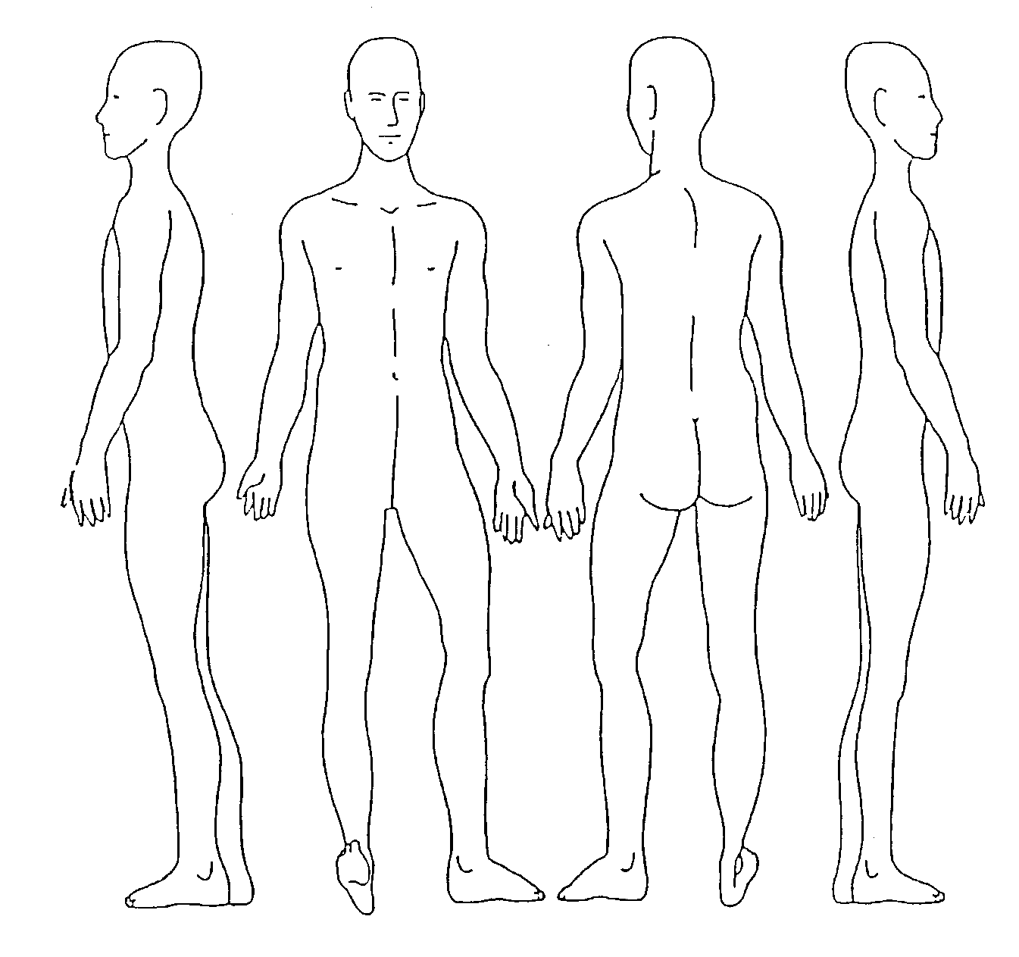
Date when the injury happened (if known) |  | Date injury below was first observed (if this is different) to the original date
Record the area/site of any injury, marks, bruising, etc. Please also indicate the rough size in centimetres or use a comparison, for example, the same size as a 10p coin. Record details such as the colour of bruising, etc.
A – Pressure trauma B – skin excoriation/grazing/reddening C – burns D – bruising E – wounds

