**Referral Form to Children and Families**

This form should **always** be completed when making a referral in respect of a child in need or in need of protection.

All urgent child protection referrals should initially be made by telephone to the Duty Desk on **686179** and then confirmed in writing within 24 hours using this form. If it is **out of hours,** please phone **631212** and the Police will contact the out of hour’s duty social worker. The form should then be sent to the Duty Team, Children and Families, 2nd Floor, Murray House, Mount Havelock, Douglas IM1 2SF or by email to [childcarereferrals.dsc@gov.im](mailto:childcarereferrals.dsc@gov.im)

You must ensure that you follow your own agency procedures re notifying relevant designated child protection officer or your line manager of this referral (see referral pathway at Annex A).

|  |  |  |  |  |  |  |  |  |  |  |
| --- | --- | --- | --- | --- | --- | --- | --- | --- | --- | --- |
|  | | |  | | | |  | |  |  |
| **Child/Young Person** | | | | | | | | | | |
| **Forename(s)** | **Surname** | **D.O.B.** | | **Gender** | **Address** | **Contact No** | | **Ethnicity** | | **Religion** |
|  |  |  | |  |  |  | |  | |  |
|  |  |  | |  |  |  | |  | |  |
|  |  |  | |  |  |  | |  | |  |
|  |  |  | |  |  |  | |  | |  |

|  |  |  |  |  |  |  |  |  |  |  |
| --- | --- | --- | --- | --- | --- | --- | --- | --- | --- | --- |
|  | |  | | | |  | | | | |
| **Other Household Members / Significant others** | | | | | | | | | | |
| **Forename(s)** | **Surname** | | **D.O.B** | **Gender** | **Address** | | **Contact No** | **Ethnicity** | **Religion** | **Relationship to the child**  **(PR Y/N)** |
|  |  | |  |  |  | |  |  |  |  |
|  |  | |  |  |  | |  |  |  |  |
|  |  | |  |  |  | |  |  |  |  |
|  |  | |  |  |  | |  |  |  |  |

|  |  |
| --- | --- |
| **Additional Needs** | |
| **Are there any additional needs for individuals which may impact communication?** | **Yes / No**  **If Yes, give details** |
| **Is an Interpreter/Signer required?** | **Yes / No** |

|  |  |
| --- | --- |
| **Significant Harm** | |
| **Has the child/ren suffered significant harm or are they at risk of suffering significant harm?** | **Yes / No**  **(If yes contact the Duty Desk as above)** |

|  |  |
| --- | --- |
| **Consent** | |
| **Has consent been gained for this referral?** | **Yes / No** |
| **from parent/person with PR?** | **If not gained, why?** |
| **From the child/young person?** | **Yes / No**  **If not gained, why?** |

|  |  |
| --- | --- |
| **Safety** | |
| **Any concerns for staff safety that professionals need to be aware of?**  *e.g history of violence/hazards* | **Yes/No**  **If Yes, please give details:** |

|  |
| --- |
| **Referral Reason** |
| **Reason for this Referral**  **Impact on the child/ren**  **The voice of the child/ren** |

|  |
| --- |
| **Action** |
| **What action have you already taken?** |
| **What action do you feel needs to be taken?** |

|  |  |
| --- | --- |
| **Early Help** | |
| **Has an Early Help assessment been completed?** | **Yes / No / Not known**  **If Yes, Date of Assessment:** |
| **Assessment(s) attached?** | **Yes / No**  **If not why?** |

|  |  |  |
| --- | --- | --- |
| **Other Professionals involved** | | |
| **Agency** | **Named Professional** | **Contact Details** |
| **School(s)** |  |  |
| **Health** |  |  |
| **Other** |  |  |

|  |  |
| --- | --- |
| **Assessment of risk *(Following the assessment Framework at Annex B)***   * **If there are concerns of Child Sexual or Criminal Exploitation complete and attach Safeguard Mnemonic (at Annex C) instead.** * **For Health staff, you may attach your completed RiC instead.** | |
| **Child’s Developmental Needs** |  |
| **Parenting Capacity** |  |
| **Family and Environmental Factors** |  |

|  |  |
| --- | --- |
| **Details of Referrer** | |
| **Name & Designation:** |  |
| **Address:** |  |
| **Email:** |  |
| **Contact No:** |  |
| **Date of Referral:** |  |

**Annex A**

**Referral Process to Children and Families Section**

Still have significant worries?

PRACTITIONER HAS CONCERNS ABOUT CHILD

Practitioner discusses concerns with agencies designated lead for child protection and/or other senior colleagues

Continue single agency provision of service and initiate EHaS if not already done so and appropriate

Practitioner makes referral to Duty Team, Children & Families. (Child protection referrals should be made verbally and followed up in writing within 24 hours)

Yes

No

Children & Families decide on next course of action within 1 working day

Feedback to referrer on next course of action within 3 working days

**Annex B**

**Assessment of Needs**

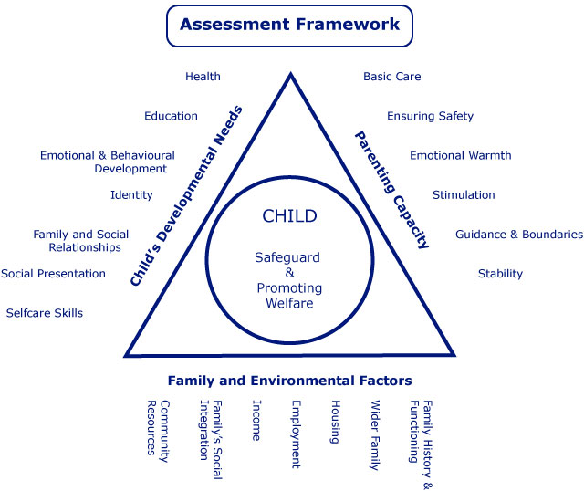

**Annex C**

**SAFEGUARD Mnemonic**

* **S**exual health and sexual behaviour concerns
* **A**bsent from school or repeatedly running away
* **F**amilial abuse and/or problems at home
* **E**motional and physical condition
* **G**angs, older age groups and involvement in crime
* **U**se of technology and sexual bullying
* **A**lcohol and drug misuse
* **R**eceipt of unexplained gifts or money
* **D**istrust of authority figures